**ARDUINO BASED FIRE FIGHTING**

**ROBOT**

**A Minor Project Report**

**Submitted in Partial fulfilment for the award of**

**Bachelor of Technology in Computer Science & Internet of**

**Things**

# Submitted to

**RAJIV GANDHI PROUDYOGIKI VISHWAVIDYALAYA**

**BHOPAL (M.P)**



**MINOR PROJECT REPORT**

# Submitted by

GAURAV PAWAR [0103IS201018]

SOMESH PAWAR [0103IS2010155]

# Under the supervision of PROF. Rampratap Singh



**Department of CSE-IOT**

**Lakshmi Narain College of Technology, Bhopal (M.P.) Session**

**MAY 2023**



# LAKSHMI NARAIN COLLEGE OF TECHNOLOGY, BHOPAL

DEPARTMENT OF CSE-IOT

# CERTIFICATE

This is to certify that the work embodied in this project work entitled **“ARDUINO BASED**

**FIRE FIGHTING ROBOT”** has been satisfactorily completed by the **GAURAV PAWAR** (18), **SOMESH PAWAR** (53), It is a Bonafide piece of work, carried out under the guidance in **Department of Computer Science & Internet of Things**, **Lakshmi Narain College of Technology, Bhopal** for the partial fulfilment of the **Bachelor of Technology** during the academic year 2022-2023.

PROF. Rampratap Singh

PROFESSOR

(GUIDE)

Approved By

**DR. VIVEK RICHHARIYA**

**Prof. & Head**

**Department of CSE-IOT**



LAKSHMI NARAIN COLLEGE OF TECHNOLOGY, BHOPAL

**DEPARTMENT OF CSE-IOT**

# **ACKNOWLEDGEMENT**

We express our deep sense of gratitude to Prof. Ram Pratap Singh (GUIDE) department of Computer Science & Internet of Things L.N.C.T., Bhopal. Whose kindness, valuable guidance and timely help encouraged me to complete this project.

A special thank goes to Dr. Vivek Richhariya (HOD) who helped me in completing this project work he exchanged his interesting ideas & thoughts which made this project work successful.

We would also thank our institution and all the faculty members without whom this project would have been a distant reality.

GAURAV PAWAR [0103IS201018]

SOMESH PAWAR [0103IS201053]

## **S.NO. TOPICS**

1. Problem Domain
2. Major objective & scope of project.
3. Problem Analysis and requirement specification
4. Detailed Design (Modeling and ERD/DFD)
5. Hardware/Software platform environment
6. Snapshots of Input & Output
7. Coding.

1. Project limitation and Future scope.

1. References.

## PROBLEM DOMAIN

For the welfare of the society, we have created an ARDUINO BASED FIRE FIGHTING

ROBOT. One of the most important parameters in a fire disaster is life, i.e., lives lost in saving someone else's life. It is sometimes impossible for fire-fighters personnel to access the site of a fire because of explosive materials, smoke, and high temperatures. A fast response to detect the fire can avoid many disastrous things. From the given statics (Fig.1), it is observed that fire can take place at domestic as well as at industrial level. A normal spark can generate a massive fire breakout. Not only the lives of industrial people but also the lives of domestic people are at risk because of poor fire management system. Fire can take many lives and can injure many people for their lifetime. But it can be avoided using proper fire controlling methods. Causes of Fire Accidents For such environments, fire- fighting robots are proposed. In today’s generation a lot of robots are proposed and designed to remove the human factor from dangerous and deadly work. The use of robots is becoming very common that safely completes the labor intensive or deadly work for human beings. A Fire Extinguishing Robot is based on IOT Technology. In Fire Extinguishing robot, we intend to build a system that could extinguish a small flame by sensing and moving to the location itself.

It will automatically detect the fire with the help of flame sensors. Once it detects the fire breakout location, it navigates itself accordingly to reach the fire source and extinguishes the fire by using built-in fire extinguishing system. For fire detection it is using three flame sensors. First one for the left direction, second one for the forward direction and third one for the right direction. Fire extinguishing systems will get activated when fire detection system detects fire. It then reaches the breakout point and the water pump will start ejecting the water when it detects fire. The key features of this system are to provide surveillance of fire so that major fire accidents can be prevented, and loss of human lives gets minimized.

## Problem Analysis and Requirement Specification

Fire disaster is one of the dangerous problems that can lead to heavy loss both financially and by taking lives. Sometimes it becomes difficult for fighters to access the site of a fire because of explosive materials, smoke, and high temperatures. Such situations risk the lives of fire fighters too. In such environments, fire-fighting robots can be useful. This Fire Extinguishing Robot is based on IOT Technology. In Fire Extinguishing Robot, we intend to build a system that could extinguish a small flame by sensing and moving to the location itself. Sometime delay in the arrival of fire fighters lead to numerous consequences. The Fire Extinguishing robot continuously monitors the environment and extinguishes it without delay.

For this project we must have deep knowledge about Arduino and its components followed by software and hardware information (Digital output controllable, Compatible with any 5V microcontroller such as Arduino., Rated through-current: 10A (NO) 5A (NC), Control signal: TTL level, Max. switching voltage 250VAC/30VDC, Max. switching current 10A, Size: 43mm x 17mm x 17mm)

## Major objective and scope of project

An Arduino based firefighting robot has been proposed which is mounted with flame sensor to detect fire in its way, temperature sensor for more accurate temperature sensing, a water to extinguish the fire detected.

To develop and design a firefighting robot by using Arduino microcontroller. Design and development of low-cost firefighting robot, to design a robot that is able to avoid obstacles, detect fire next extinguish fire. Run automatically firefighting robot, to determine the use of multiple sensors for various sensing on the robot. To reduce and save human life especially fire man who expose to danger while extinguish the fire

Talking about the scope of the project it has a wide scope as it is automated and requires less or zero manpower.

## Problem Analysis and Requirement Specification

Fire disaster is one of the dangerous problems that can lead to heavy loss both financially and by taking lives. Sometimes it becomes difficult for fighters to access the site of a fire because of explosive materials, smoke, and high temperatures. Such situations risk the lives of fire fighters too. In such environments, fire-fighting robots can be useful. This Fire Extinguishing Robot is based on IOT Technology. In Fire Extinguishing Robot, we intend to build a system that could extinguish a small flame by sensing and moving to the location itself.

Sometime delay in the arrival of fire fighters lead to numerous consequences. The Fire

Extinguishing robot continuously monitors the environment and extinguishes it without delay.

For this project we must have deep knowledge about Arduino and its components followed by software and hardware information (Digital output controllable, Compatible with any 5V microcontroller such as Arduino., Rated through-current: 10A (NO) 5A (NC), Control signal: TTL level, Max. switching voltage 250VAC/30VDC, Max. switching current 10A, Size: 43mm x 17mm x 17mm)

## Introduction

The project that is being presented is focused on a firefighting robot. Robots can perform tasks in a more efficient, cost-effective, and accurate manner than humans. It has grown in popularity as technology has advanced, making human work simpler. The firefighting robot is programmed to scan for and extinguish fires in affected areas. The consequences of fire cannot be prevented, and they can occur in both young, newly formed forests and mature natural forests. Fire has a focused impact on plant growth because it destroys undesirable vegetation, allowing other species to emerge. To occupy Gas sensor, tank which consists of water, wireless remote, wireless android device and Wi-Fi powered camera are all important components in the robot’s construction. A wireless robot can conduct successful work, allowing the robot to be operated from a distance. LTDAR is an algorithm developed ultraviolet radiation sensor to reliably find fire using a long wave infrared camera and created for a mobile intelligent firefighting robot. The act of sprinkling water on a fire is known as firefighting. The robotic vehicle is equipped with water tanks and a pump that is operated by wireless communication. As a result of a fire outbreak (or) fire explosion, we are demanding that we use human resources that are not secure to put out the fire. It is very much possible to replace human work in putting out a fire in a dangerous environment by using higher technology, specifically robotics. This strategy would free firefighters from dangerous tasks, increase their efficiency, and reduce the number of fires. Moreover, According to National Crime Records Bureau (NCRB), it is estimated that more than 1.2 lakh deaths have been caused because of fire accidents in India from 2010-2014. Even though there are a lot of precautions taken for Fire accidents, these natural/man-made disasters do occur now and then. In the event of a fire breakout, to rescue people and to put out the fire we are forced to use human resources which are not safe. With the advancement of technology, especially in robotics, it is very much possible to replace humans with robots for fighting fire. This would improve the efficiency of firefighters and would also prevent them from risking human lives. Today we are going to build a Fire Fighting Robot using

Arduino, which will automatically sense the fire and start the water pump.

In this project, we will learn how to build a simple robot using Arduinothat could move towards the fire and pump out water around it to put down the fire. It is a very simple robot that would teach us the underlying concept of robotics; you would be able to build more sophisticated robots once you understand the following basics. So, let’s get started...

## Detailed design of the project

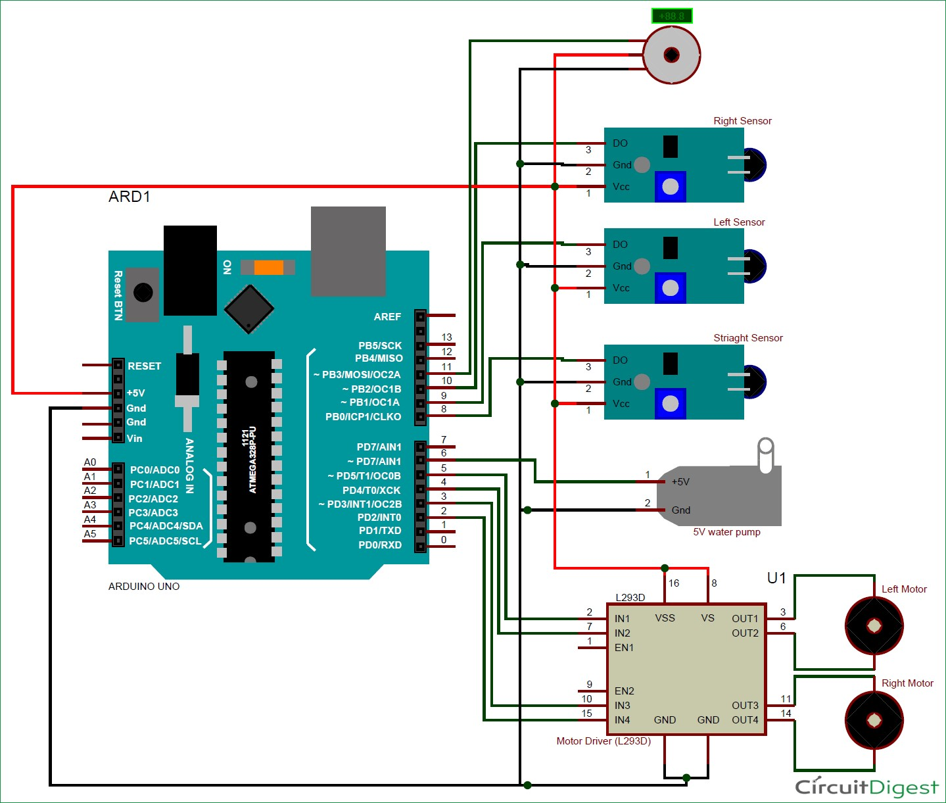

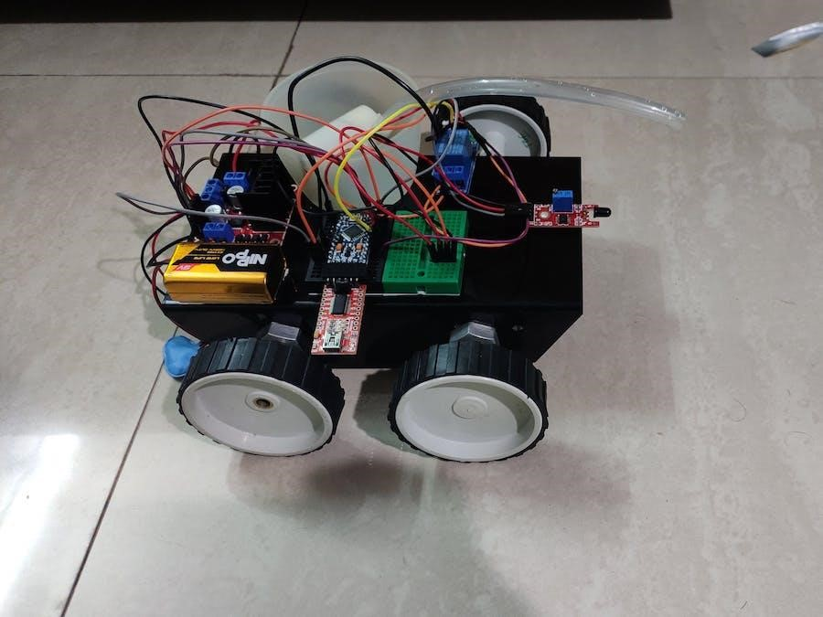

MODEL

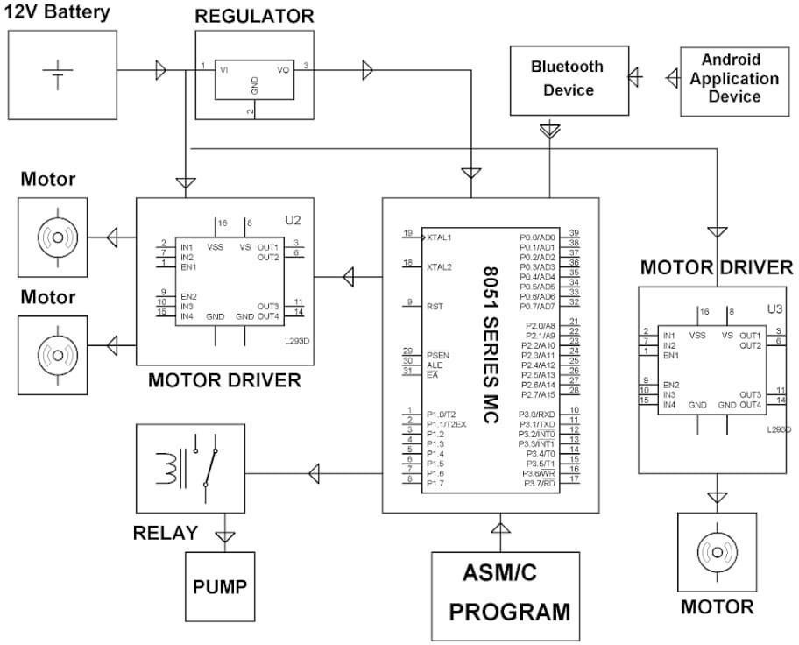

CIRCUIT DIAGRAM

HARDWARE COMPONENTS

Arduino UNO:

A Microcontroller is a compact device with a processor, storage and configurable input/output devices on a single integrated circuit. We'll be using the Arduino UNO board, which combines a microcontroller with all the extras needed to quickly create and debug projects. The ATmega3288based UNO is a microcontroller board. The Arduino Unois an open-source microcontroller board based.

The Microchip ATmega328P microcontroller and developed by Arduino.cc and initially released in 2010.The board is equipped with sets of digital and analog input/output (I/O) pins that may be interfaced to various expansion boards (shields) and other circuits. The board has 14 digital I/O pins (six capable of PWM output), 6 analog I/O pins, and is programmable with the Arduino IDE (Integrated Development Environment), via a type B USB cable. It can be powered by the USB cable or by an external 9-volt battery, though it accepts voltages between 7 and 20 volts. It is like Arduino Nano and Leonardo. The hardware reference design is distributed under a Creative Commons Attribution Share-Alike 2.5 license and is available on the Arduino website. Layout and production files for some versions of the hardware are also available.

The word "uno" means "one" in Italian and was chosen to mark the initial release of Arduino Software The Uno board is the first in a series of USB-based Arduino boards it and version 1.0 of the Arduino IDE were the reference versions of Arduino, which have now evolved to newer releases The ATmega328 on the board comes preprogrammed with a boot loader that allows uploading new code to it without the use of an external hardware programmer

While the Uno communicates using the original STK500 protocol it differs from all preceding

boards in that it does not use the FTDI USB-to-serial driver chip. Instead, it uses the

Atmega16U2 (Atmega8U2 up to version R2) programmed as a USB-to-serial converter.

It has,

1. 14 Digital input/output pins,
2. 6 Analog inputs,
3. 16MHz Quartz crystal,
4. USB connector,

\5. Power jack,

6. ICSP header, 7. Reset button.

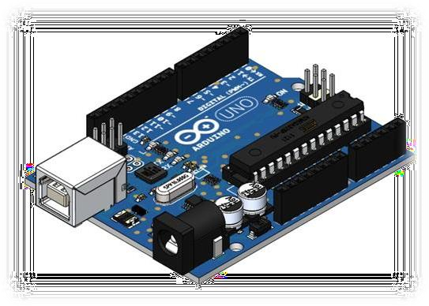

Arduino UNO

Flame Sensor (IR):

A flame sensor is the most sensitive to normal light of any sensor. This sensor senses flame if the light source emits a wavelength between 760nm and 1100nm. The detection angle would be 60o and can be achieved from 100cm (about 3.28 ft).

This sensor's output is either an analog or digital signal. The infrared flame flash method is used by this sensor. A flame detector is a sensor designed to detect and respond to the presence of a flame or fire, allowing flame detection.

Responses to a detected flame depend on the installation, but can include sounding an alarm, deactivating a fuel line (such as a propane or a natural gas line), and activating a fire suppression system. When used in applications such as industrial furnaces, their role is to provide confirmation that the furnace is working properly; it can be used to turn off the ignition system though in many cases they take no direct action beyond notifying the operator or control system.

A flame detector can often respond faster and more accurately than a smoke or heat detector due to the mechanisms it uses to detect the flame.

It has four pins,

1. Voltage Supply (Vcc),
2. Ground pin (GND),
3. Analog output (Aout),
4. Digital output (Do)

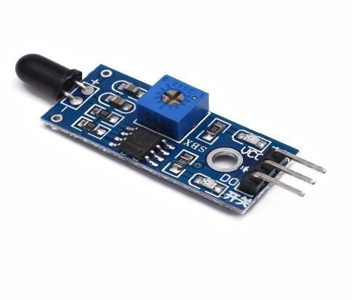

Flame Sensor (IR)

Temperature Sensor (LM35):

The temperature sensors in the LM35 series are accuracy integrated circuits temperature sensors with a linearly proportional output voltage to Celsius scale value. The Temperature can be measured more precisely than with a thermistor. Temperature Sensor (LM35) The sensor circuitry is fully sealed and is not exposed to the elements. Due to oxidation The LM35 produces a higher output voltage than thermocouples, so it might not be necessary to amplify the output voltage. It calibrates in Celsius with a 0.5°C precision guarantee and a measurable range of 55°Cto+150°C. The integrated circuit sensors may come in a variety of interfaces — analogue or digital; for digital, these could Serial Peripheral Interface, SMBus/I2C or 1-Wire.

In OpenBSD, many of the I2C temperature sensors from the below list have been supported and are accessible through the generalized hardware sensors framework since OpenBSD 3.9 (2006), which has also included an ad-hoc method of automatically scanning the I2C bus by default during system boot since 2006 as well.  In NetBSD, many of these I2C sensors are also supported and are accessible through the envsys framework, although none are enabled by default outside of Open Firmware architectures like macppc, and a manual configuration is required before first use on i386 or amd64. Remote uncooled IR thermal radiometer sensors are also commonly used in integrated circuits.

The integrated circuit sensors may come in a variety of interfaces — analogue or digital; for digital, these could be Serial Peripheral Interface, SMBus/I2C or 1-Wire. In OpenBSD, many of the I2C temperature sensors from the below list have been supported and are accessible through the generalized hardware sensors framework since OpenBSD 3.9 (2006),which has also included an adhoc method of automatically scanning the I2C bus by default during system boot since 2006 as well.

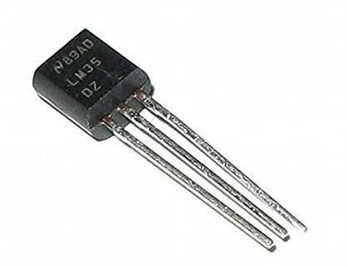

Temperature Sensor (LM35)

Servo Motor:

Servo motors are high torque motors which are commonly used in robotics and several other applications due to the fact that it’s easy to control their rotation. Servo motors have a geared output shaft which can be electrically controlled to turn one (1) degree at a time. For the sake of control, unlike normal DC motors, servo motors usually have an additional pin aside the two power pins (VCC and GND) which is the signal pin. The signal pin is used to control the servo motor, turning its shaft to any desired angle.

A servomotor (or servo motor) is a rotary actuator or linear actuator that allows for precise control of angular or linear position, velocity and acceleration. It consists of a suitable motor coupled to a sensor for position feedback. It also requires a relatively sophisticated controller, often a dedicated module designed specifically for use with servomotors. Servomotors are not a specific class of motor, although the term servomotor is often used to refer to a motor suitable for use in a closed-loop control system. Servomotors are used in applications such as robotics, CNC machinery, and automated manufacturing.

A servo consists of a Motor (DC or AC), a potentiometer, gear assembly, and a controlling circuit. First of all, we use gear assembly to reduce RPM and to increase torque of the motor. Say at initial position of servo motor shaft, the position of the potentiometer knob is such that there is no electrical signal generated at the output port of the potentiometer. Now an electrical signal is given to another input terminal of the error detector amplifier. Now the difference between these two signals, one comes from the potentiometer and another comes from other sources, will be processed in a feedback mechanism and output will be provided in terms of error signal. This error signal acts as the input for motor and motor starts rotating. Now motor shaft is connected with the potentiometer and as the motor rotates so the potentiometer and it will generate a signal. So as the potentiometer’s angular position changes, its output feedback signal changes. After sometime the position of potentiometer reaches at a position that the output of potentiometer is same as external signal provided. At this condition, there will be no output signal from the amplifier to the motor input as there is no difference between external applied signal and the signal generated at potentiometer, and in this situation motor stops rotating.

A servomotor is a closed-loop servomechanism that uses position feedback to control its motion and final position. The input to its control is a signal (either analogue or digital) representing the position commanded for the output shaft.The motor is paired with some type of position encoder to provide position and speed feedback. In the simplest case, only the position is measured. The measured position of the output is compared to the command position, the external input to the controller. If the output position differs from that required, an error signal is generated which then causes the motor to rotate in either direction, as needed to bring the output shaft to the appropriate position. As the positions approach, the error signal reduces to zero and the motor stops.The very simplest servomotors use position-only sensing via a potentiometer and bang bang control of their motor; the motor always rotates at full speed (or is stopped). This type of servomotor is not widely used in industrial motion control, but it forms the basis of the simple and cheap servos used for radio-controlled models.

More sophisticated servomotors use optical to measure the speed of the output shaft and a variable-speed drive to control the motor speed. BothBoth of these enhancements, usually in combination with a PID control algorithm, allow the servomotor to be brought to its commanded position more quickly and more precisely, with less overshooting enhancements, usually in combination with an algorithm, allow the servomotor to be brought to brought to its commanded position more quickly and more precisely, with less overshooting.



Servo Motor

DC MOTORS:

In this robot, 12V geared DC motors are attached to the wheels. Geared DC motors are available with wide range of RPM and Torque, which allow a robot to move based on the control signal it receives from the motor driver IC. The L293D is a dual H-bridge motor driver integrated circuit (IC). The Motor drivers act as current amplifiers since they take a low-current control signal and provide a higher-current signal. This higher current signal is used to drive the motors. It has 16 pins. A DC motoris any of a class of rotary electrical motors that converts direct current (DC) electrical energy into mechanical energy. The most common types rely on the forces produced by induced magnetic fields due to flowing current in the coil.

Nearly all types of DC motors have some internal mechanism, either electromechanical or electronic, to periodically change the direction of current in part of the motor. DC motors were the first form of motors widely used, as they could be powered from existing directcurrent lighting power distribution systems. A DC motor's speed can be controlled over a wide range, using either a variable supply voltage or by changing the strength of current in its field windings. Small DC motors are used in tools, toys, and appliances. The universal motor lightweight motor used for portable power tools and appliances can operate on direct current and alternating current.

Larger DC motors are currently used in propulsion of electric vehicles, elevators and hoists, and in drives for steel rolling mills. The advent of power electronics has made replacement of DC motors with AC motor possible in many applications. A coil of wire with a current running through it generates an electromegnetic field aligned with the center of the coil. The direction and magnitude of the magnetic field produced by the coil can be changed with the direction and magnitude of the current flowing through it. A simple DC motor has a stationary set of magnets in the stator and an with one or more windings of insulated wire wrapped around a soft iron core that concentrates the magneticfield. The windings usually have multiple turns around the core, and in large motors there can be several parallel current paths. The ends of the wire winding are connected to a commutator. [T](https://en.wikipedia.org/wiki/Commutator_(electric))he commutator allows each armature coil to be energized in turn and connects the rotating coils with the external power supply through brushes. (Brushless DC motors have electronics that switch the DC current to each coil on and off and have no brushes.) The total amount of current sent to the coil, the coil's size, and what it is wrapped around decide the strength of the electromagnetic field created.

The sequence of turning a particular coil on or off dictates what direction the effective electromagnetic fields are pointed in. By turning on and off coils in sequence, a rotating magnetic field can be created. These rotating magnetic fields interact with the magnetic fields of the magnets (permanent or electromegnet) in the stationary part of the motor (stator) to create a torque on the armature which causes it to rotate. In some DC motor designs, the stator fields use electromagnets to create their magnetic fields which allows greater control over the motor.

A series motor should never be started at no load. With no mechanical load on the series motor, the current is low, the counter-Electro motive force produced by the field winding is weak, and so the armature must turn faster to produce sufficient counter-EMF to balance the supply voltage. The motor can be damaged by overspeed. This is called a runaway condition. Series motors called universal motors can be used on alternating current. Since the armature voltage and the field direction reverse at the same time, torque continues to be produced in the same direction. However they run at a lower speed with lower torque on AC supply when compared to DC due to reactance voltage drop in AC which is not present in DC.[3] Since the speed is not related to the line frequency, universal motors can develop higher-than-synchronous speeds, making them lighter than induction motors of the same rated mechanical output. This is a valuable characteristic for hand-held power tools. Universal motors for commercial utility are usually of small capacity, not more than about 1 kW output.

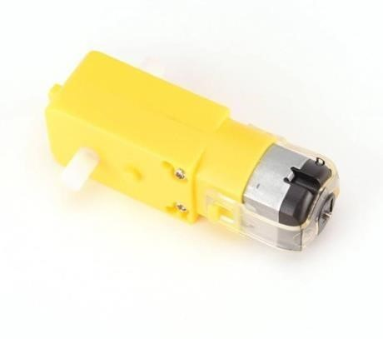

DC MOTORS

MOTOR DRIVER:

The L293D is a dual channel motor driver IC capable of driving dual DC motors with bidirectional control and a single stepper motor. The L293D devices are quadruple high current half-H drivers. The L293D is designed to provide bidirectional drive currents of up to 600-mA at voltages from 4.5 V to 36 V. This IC is also designed to drive inductive loads such as relays, solenoids, DC and bipolar stepping motors also. The L293D is most often used to drive motors but because of its totem pole output driver it can be used to drive solenoids, four uni-directional DC motors, two bi-directional DC motors or one stepper motor. For further information on this

IC, you can check the datasheet of L293D IC. Follow the links to learn more about Motor driver ICs and L293D. The L293 IC does not have the flyback diodes built in, so you need to add those in your circuit if you are using the L293 version.

The L293D version has all the flyback diodes connected internally so for the L293D IC you don't need to connect external diodes. The L293D IC receives signals from the microprocessor and transmits the relative signal to the motors. It has two voltage pins, one of which is used to draw current for the working of the L293D and the other is used to apply voltage to the motor. It is capable of driving four solenoids, four unidirectional DC motors, two bi-directional DC motors or one stepper motor. The L293D IC has a supply range of 4.5V to 36V and is capable of 1.2A peak output current per channel, so it works very well with most of our motors. The L293D does not have any speed controlling capabilities. You need to use PWM from a microcontroller or any other source on the enable pin of the IC to control the speed of the motor.

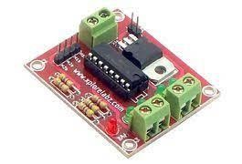

MOTOR DRIVER

WATER PUMP:

Submersible pump, also called an electric submersible pump, is a pump that can be fully submerged in water. The motor is hermetically sealed and close-coupled to the body of the pump. A submersible pump pushes water to the surface by converting rotary energy into kinetic energy into pressure energy. This is done by the water being pulled into the pump: first in the intake, where the rotation of the impeller pushes the water through the diffuser. From there, it goes to the surface.The major advantage to a submersible pump is that it never has to be primed, because it is already submerged in the fluid. Submersible pumps are also very efficient because they don’t really have to spend a lot of energy moving water into the pump.

Water pressure pushes the water into a submersible pump, thus “saving” a lot of the pump’s energy. Also, while the pumps themselves aren’t versatile, the selection certainly is. Some submersible pumps can easily handle solids, while some are better for liquids only.

Submersible pumps are quiet, because they are under water, and cavitation is never an issue, because there is no “spike” in pressure as the water flows through the pump. The pump shaft is connected to the gas separator or the protector by a mechanical coupling at the bottom of the pump. Fluids enter the pump through an intake screen and are lifted by the pump stages. Other parts include the radial bearings distributed along the length of the shaft, providing radial support to the pump shaft. An optional thrust bearing takes up part of the axial forces arising in the pump, but most of those forces are absorbed by the protector's thrust bearing.

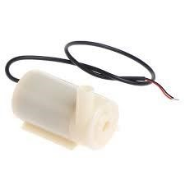

WATER PUMP

JUMPER WIRE:

Jumper wires are simply wires that have connector pins at each end, allowing them to be used to connect two points to each other without soldering. Jumper wires are typically used with breadboards and other prototyping tools in order to make it easy to change a circuit as needed. Fairly simple. In fact, it doesn’t get much more basic than jumper wires. Though jumper wires come in a variety of colors, the colors don’t actually mean anything. This means that a red jumper wire is technically the same as a black one. But the colors can be used to your advantage in order to differentiate between types of connections, such as ground or power. While jumper wires are easy and inexpensive to purchase, it can also be a fun task to challenge students to make their own. Doing so requires insulated wire and wire strippers. However, beware that it is important not to nick the wire when stripping off the insulation. Jumper wires typically come in three versions: male-to-male, male-to-female and female-tofemale. The difference between each is in the end point of the wire. Male ends have a pin protruding and can plug into things, while female ends do not and are used to plug things into. Male-to-male jumper wires are the most common and what you likely will use most often.

When connecting two ports on a breadboard, a male-to-male wire is what you’ll need. Their function is to configure the settings for computer peripherals, like the motherboard. Suppose your motherboard supported intrusion detection. A jumper can be set to enable or disable it. Jumper wires are electrical wires with connector pins at each end. They are used to connect two points in a circuit without soldering. You can use jumper wires to modify a circuit or diagnose problems in a circuit. Further, they are best used to bypass a part of the circuit that does not contain a resistor and is suspected to be bad. This includes a stretch of wire or a switch. Suppose all the fuses are good and the component is not receiving power; find the circuit switch. Then, bypass the switch with the jumper wire.

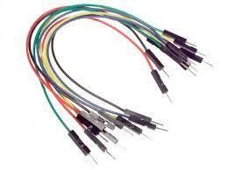

JUMPER WIRE

BREADBOARD:

A breadboard is a solderless construction base used for developing an electronic circuit and wiring for projects with microcontroller boards like Arduino. As common as it seems, it may be daunting when first getting started with using one. A breadboard, solderless breadboard, or protoboard is a construction base used to build semi-permanent prototypes of electronic circuits. A perfboard or stripboard, breadboards do not require soldering or destruction of tracks and are hence reusable. For this reason, breadboards are also popular with students and in technological education. A variety of electronic systems may be prototyped by using breadboards, from small analog and digital circuits to complete central processing units (CPUs) Compared to more permanent circuit connection methods, modern breadboards have high parasitic capacitance, relatively high resistance, and less reliable connections, which are subject to jostle and physical degradation. Signaling is limited to about 10 MHz, and not everything works properly even well below that frequency. A breadboard (sometimes called a plug block) is used for building temporary circuits. It is useful to designers because it allows components to be removed and replaced easily. It is useful to the person who wants to build a circuit to demonstrate its action, then to reuse the components in another circuit. There many breadboard-friendly components that are available for us to use and prototype with. We can easily identify breadboard-friendly components by their footprint.

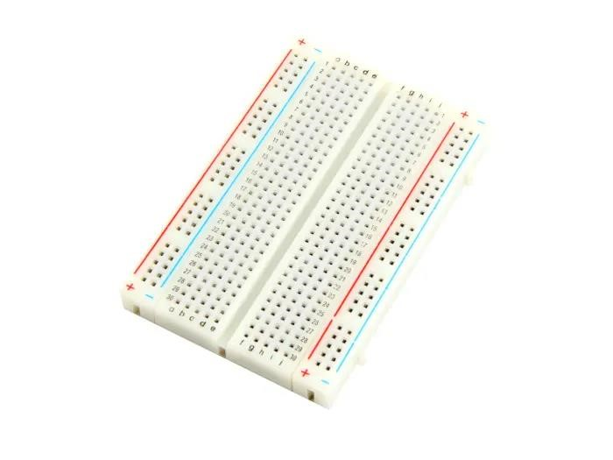

BREADBOARD

BATTERY:

A battery is a source of electric power consisting of one or more electrochemical cells with external connections for powering electrical devices. When a battery is supplying power, its positive terminal is the cathode, and its negative terminal is the anode. The terminal marked negative is the source of electrons that will flow through an external electric circuit to the positive terminal. When a battery is connected to an external electric load, a redox reaction converts high-energy reactants to lower-energy products, and the free-energy difference is delivered to the external circuit as electrical energy. Historically the term "battery" specifically referred to a device composed of multiple cells; however, the usage has evolved to include devices composed of a single cell.

Primary (single-use or "disposable") batteries are used once and discarded, as the electrode materials are irreversibly changed during discharge; a common example is the alkaline battery used for flashlights and a multitude of portable electronic devices. Secondary (rechargeable) batteries can be discharged and recharged multiple times using an applied electric current; the original composition of the electrodes can be restored by reverse current. Examples include the lead–acid batteries used in vehicles and lithium-ion batteries used for portable electronics such as laptops and mobile phones.

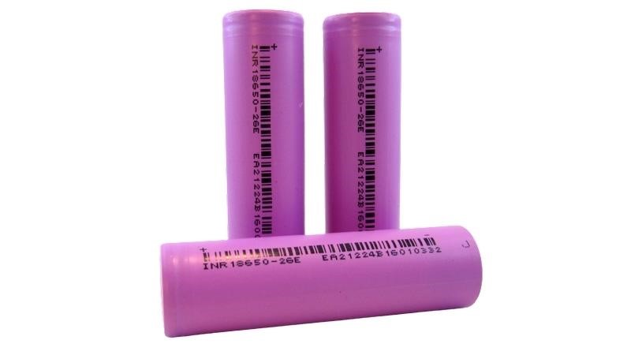

BATTERY

## Coding

## #include <Servo.h> //include servo.h library Servo myservo;

int pos = 0; boolean fire = false;

#define Left 9 // left sensor

#define Right 10 // right sensor

#define Forward 8 //front sensor

|  |  |
| --- | --- |
| #define LM1 2 | // left motor |
| #define LM2 3 | // left motor |
| #define RM1 4 | // right motor |
| #define RM2 5  #define pump 6 | // right motor |

void setup ()

{

PinMode (Left, INPUT); pinMode (Right, INPUT); pinMode (Forward, INPUT); pinMode(LM1,

OUTPUT); pinMode(LM2,

OUTPUT); pinMode(RM1,

OUTPUT); pinMode(RM2,

OUTPUT); pinMode(pump,

OUTPUT);

myservo.attach(11); myservo.write(90);

void put_off_fire()

{ delay (500);

digitalWrite(LM1, HIGH); digitalWrite(LM2, HIGH); digitalWrite(RM1, HIGH); digitalWrite(RM2, HIGH);

digitalWrite(pump, HIGH); delay (500);

for (pos = 50; pos <= 130; pos += 1) { myservo.write(pos); delay (10);

} for (pos = 130; pos >= 50; pos = 1) { myservo.write(pos); delay (10);

}

digitalWrite(pump,LOW); myservo.write(90);

fire=false;

}

void loop ()

{

myservo.write(90); //Sweep Servo ();

if (digitalRead (Left) ==1 && digitalRead (Right)==1 && digitalRead(Forward) ==1)

{

digitalWrite(LM1, HIGH); digitalWrite(LM2, HIGH); digitalWrite(RM1, HIGH); digitalWrite (RM2, HIGH);

}

else if (digitalRead(Forward) ==0)

{ digitalWrite(LM1, HIGH); digitalWrite(LM2, LOW); digitalWrite(RM1, HIGH); digitalWrite(RM2, LOW);

fire = true;

}

else if (digitalRead(Left) ==0)

{ digitalWrite(LM1, HIGH); digitalWrite(LM2, LOW); digitalWrite(RM1, HIGH); digitalWrite(RM2, HIGH);

}

else if (digitalRead(Right) ==0)

{

digitalWrite(LM1, HIGH); digitalWrite(LM2, HIGH);

digitalWrite(RM1, HIGH);

digitalWrite(RM2, LOW);

}

delay (300);//change this value to increase the distance

while (fire == true)

{ put_off_fire();

}

}

## Project limitations and future scope

Talking about the limitation of project , it cannot be used for a large scale fire and as no human is involved the percentage of error is more , many believes it will be better scout than fire fighter ,cannot leave outside for long period of time due to battery life it is not meant to put out large fire , no remote control for the robotic moment , communication device mostly use similar frequency ,so interference occurs if the address are not specified

. Data rate transmission is lower than wired transmission, it cannot be worked beyond the limit and this project is also high in cost.

Further the project can be enhanced by interfacing it with a wireless camera. The camera is mounted on the motor, so it rotates in all directions and captures the images or the video. so that the person can view the operation of the robot.

## References

[1]. Control of an Autonomous Industrial Fire Fighting Mobile Robot by HP SINGH, Department of Mathematics, Sri Venkateswara College, University of Delhi

[2]. An Autonomous Firefighting Robot Real Time Man-Robot Control of a Group of Specialized Mobile Robots Vassil Sgurev, Stanislav Drangajov, Lyubka Doukovska Institute of Information and Communication Technologies, 1113 Sofia

[3]. A System Architecture of Wireless Communication for FireFighting Robot by Korea

Advanced Institute of Science and Technology (KAIST), 335 Gwahangno, Yuseong-gu, Daejeon 305-701, Republic of Korea

[4]. Develop a Multiple Interface Based Fire Fighting Robot by 1Department of Electronic Engineering WuFeng Institute of Technology Ming-Hsiung

[5]. FIRE FIGHTING ROBOT Sahil S. Shah1, Vaibhav K. Shah2, Prithvish Mamtora3 and

Mohit Hapani4 1,2,3,4D.J. Sanghvi College of Engineering, Vile Parle – West, Mumbai, India

[6]. Development of a Firefighting Robot for Educational Competitions by Taiser T. T. Barros and Walter Fetter Lages Electrical Engineering Department Federal University of Rio Grande do Sul Porto Alegre.

[7]. https://[www.arduino.cc/en/Main/ArduinoBoardUno](http://www.arduino.cc/en/Main/ArduinoBoardUno)

[8]. <http://www.slideshare.net/maastech/robotics-projects-abstractfirefighting-robot-with>